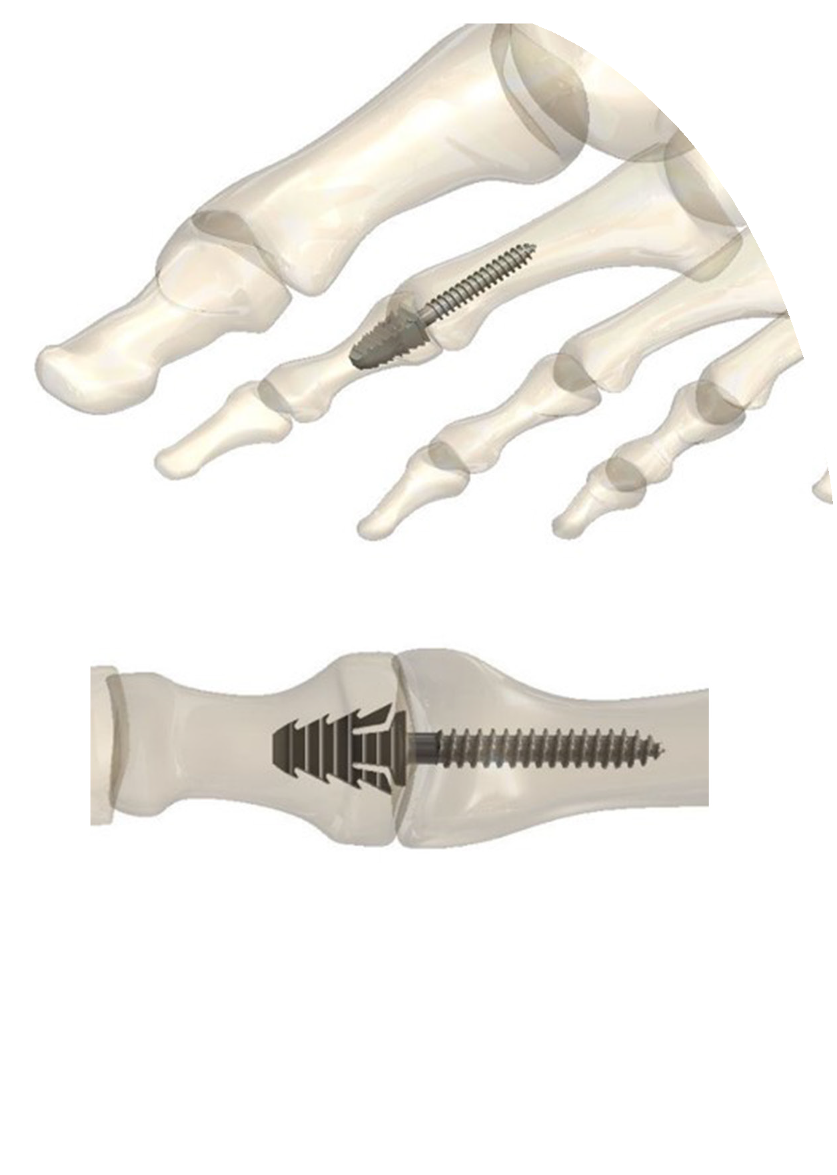FuseFix HammerToe

Titanium
Solid & Cannulated Option Straight & Angled Option Integrated Instrument Design Sterile Packaged

Features and Benefits
The comprehensive FuseFix HammerToe was designed to provide the surgeon with speed of the procedure and accurate placement of the screw. The FuseFix HammerToe exhibits the following advantages:

- No additional instrumentation for a faster procedure
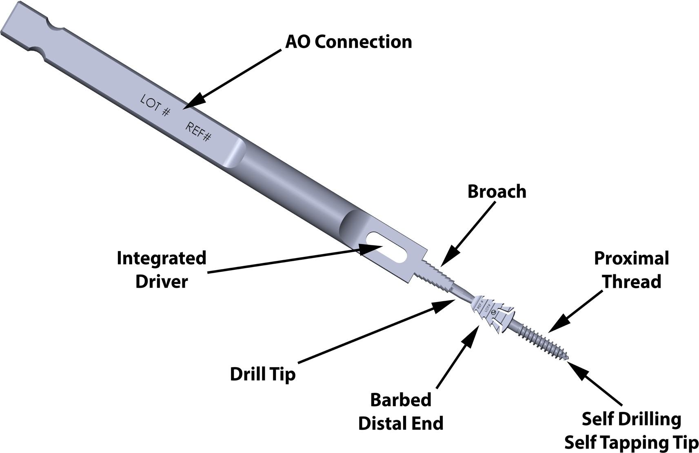
- Built in AO Connection
- Integrated instruments including drill & broach
- Barbed distal end for enhanced bone purchase and fixation
- Screws contain self-drilling and tapping features

Powered By

Phone: (972) 331-5900 www.fusemedical.com
Please email schedule@surgicalservice.com to place orders or schedule cases

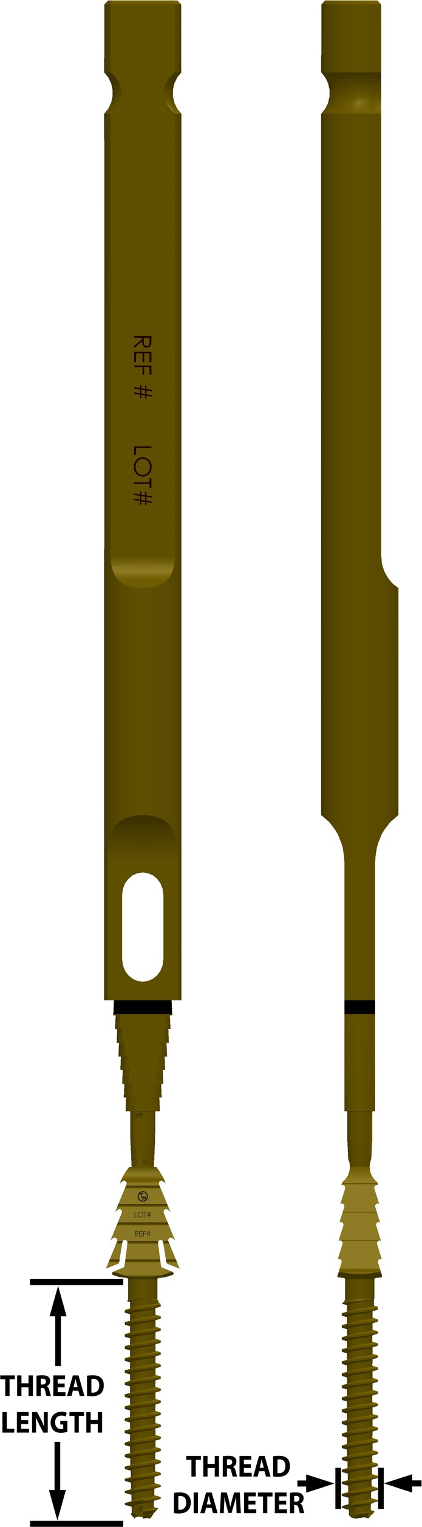
Implant - Ø2.0 Screw

Ø2.0 Screw
Part # | Length | Description
M13-C20013 | 13mm | FuseFix Cannulated Ø2.0mm x 13mm
M13-S20013 | 13mm | FuseFix Solid 0° Ø2.0mm x 13mm
M13-S20113 | 13mm | FuseFix Solid 10° Ø2.0mm x 13mm

Implant - Ø2.5 Screw

Ø2.5 Screw
Part # | Length | Description
M13-C25015 | 15mm | FuseFix Cannulated Ø2.5mm x 15mm
M13-S25015 | 15mm | FuseFix Solid 0° Ø2.5mm x 15mm
M13-S25115 | 15mm | FuseFix Solid 10° Ø2.5mm x 15mm

Implant - Ø3.0 Screw

Ø3.0 Screw
Part # | Length | Description
M13-C30015 | 15mm | FuseFix Cannulated Ø3.0mm x 15mm
M13-S30015 | 15mm | FuseFix Solid 0° Ø3.0mm x 15mm
M13-S30115 | 15mm | FuseFix Solid 10° Ø3.0mm x 15mm

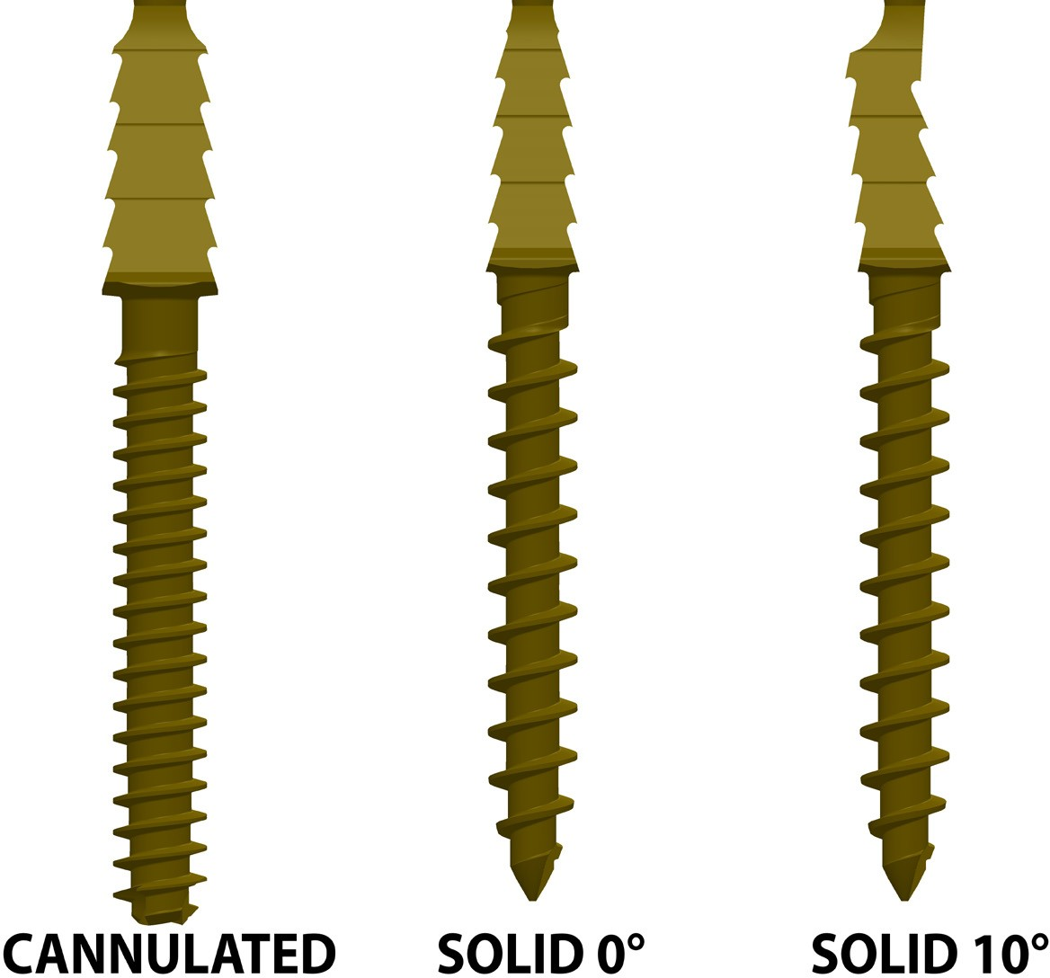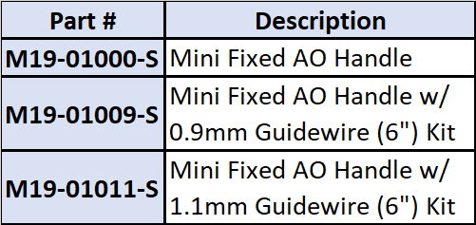

Powered By

Phone: (972) 331-5900 www.fusemedical.com
Please email schedule@surgicalservice.com to place orders or schedule cases

